

Cloud Development

POE PART 1



sIPHESIHLE ZWANE

ST10443356

Table of Contents

Github Repo Link 2

Azure Link 2

Screenshots 2

D. Cloud Computing Basics 4

Referencing 8

### Github Repo Link

### https://github.com/ST10443356-Siphesihle-Zwane/CloudPOEPart1.git

### Azure Link

eventeasesz.azurewebsites.net

### Screenshots

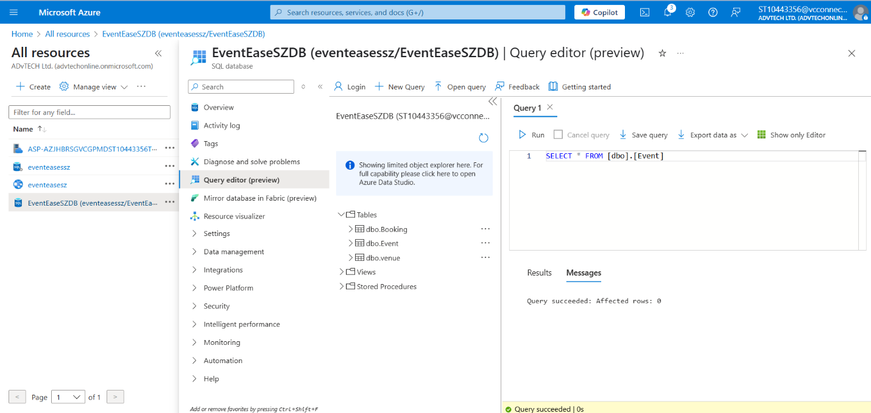

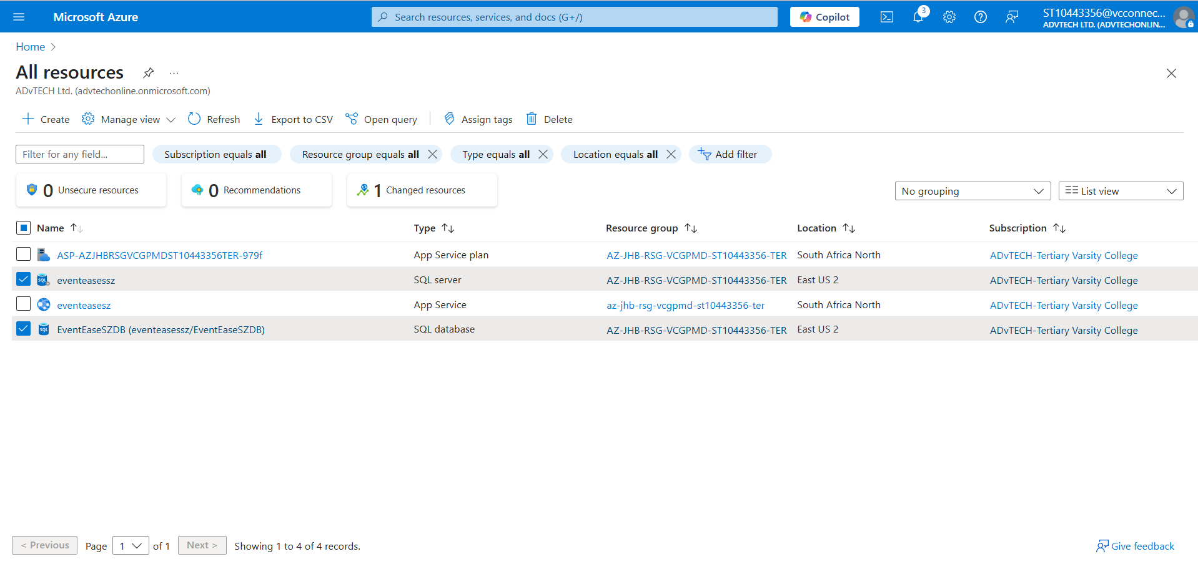

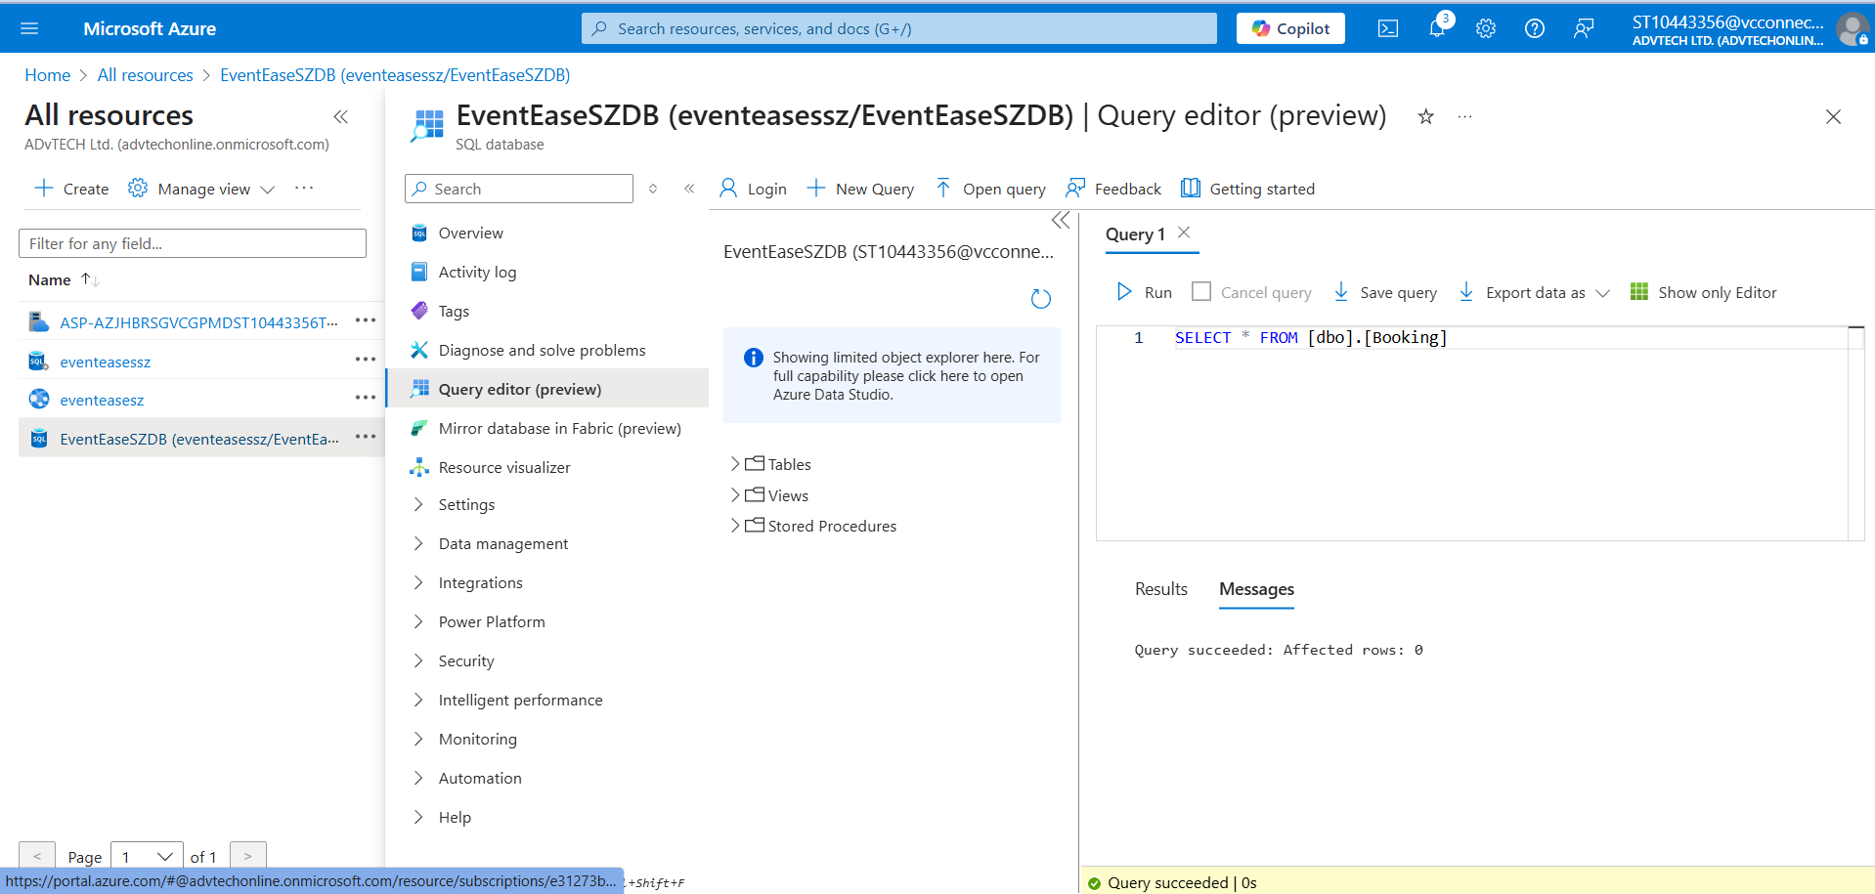



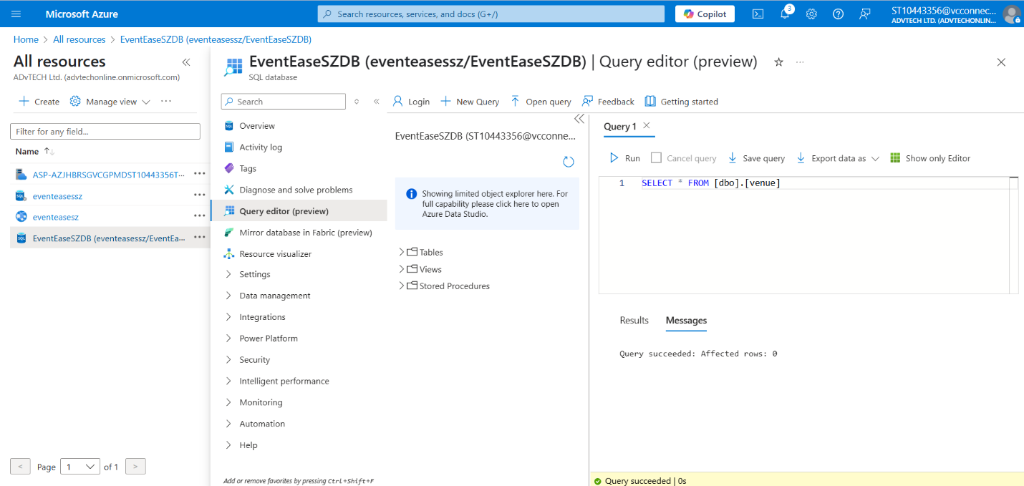

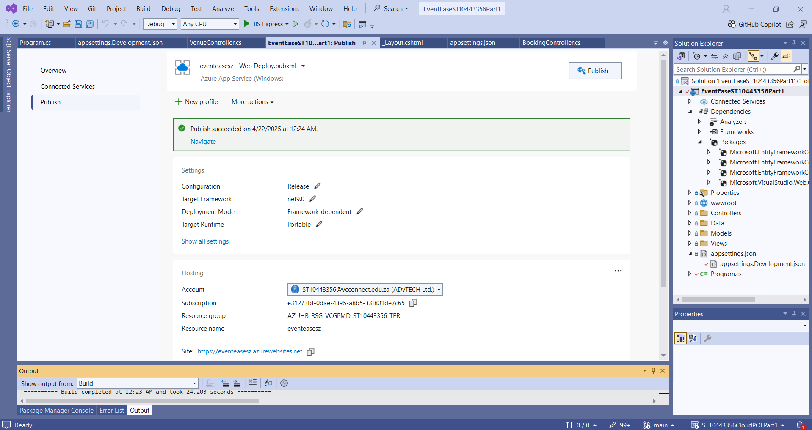

## D. Cloud Computing Basics

Number 1

Security

* Cloud: It is usually managed by a cloud provider who makes use of things such as firewalls, encryption and access controls built-in (Microsoft, 2023). An example would be Azure or AWS.
* On-Premises: The business handles all matters tied to security, including firewall configuration, intrusion detection and system updates.

Deployment speed

* Cloud: Services such as AWS Elastic Beanstalk, Azure App Services and other automated services can be used to deploy applications in a matter of minutes (Microsoft, 2023).
* On-Premises: Factors such as manual provisioning and configuration of servers can prolong the deployment of an application, leading to apps taking more than an upwards to 2 days to deploy completely.

Resource Management

* Cloud: Resources are adjusted based on demand, thanks to Auto-scaling (AWS, 2023). An example would be AWS Auto Scaling.
* On-Premises: Higher costs and potential downtime due to businesses having to physically upgrade servers and manage storage.

Example

Taking EventEase as an example:

* Deploying on Azure or AWS would provide fast deployment, automatic scaling, and built-in security.
* On-premises deployment would require purchasing physical servers, IT staff, and security infrastructure, making it costly and time-consuming.

Number 2

**Infrastructure as a Service (IaaS)**

“Virtualized computing resources, including virtual machines, networking, and storage, are made available to organizations via Infrastructure as a Service (IaaS) and can be set up according to particular needs" (IBM, 2024). With this, businesses can fully manage their infrastructure without having to worry about maintaining real servers (Google Cloud, 2024). IaaS solutions that provide dynamic resource scaling for enterprises include Google Compute Engine, AWS EC2, and Azure Virtual Machines. IaaS is perfect for businesses who don't want to spend money on on-premises hardware but yet need substantial flexibility, control, and unique configurations for their IT environment (TechTarget, 2024). However, as companies are in charge of maintaining their operating systems, security patches, and application configurations, administering IaaS still calls for IT know-how.

**Platform as a Service (PaaS)**

With Platform as a Service (PaaS), developers can concentrate on creating code while the cloud provider takes care of infrastructure, security, and scaling (Microsoft Azure, n.d.). PaaS provides a completely managed platform for development and deployment (IBM, n.d.). AWS Elastic Beanstalk, Azure App Services, and Google App Engine are a few examples of PaaS that make it easier to deploy apps without forcing companies to maintain the underlying infrastructure (DigitalOcean, n.d.). Because it speeds up development cycles and simplifies infrastructure administration, this architecture is especially advantageous for businesses creating specialized applications (Red Hat, n.d.). Businesses may lower maintenance expenses while maintaining the security and efficiency of their apps because the cloud provider takes care of updates, security patches, and scalability automatically (Clever Cloud, 2025).

**Software as a Service (SaaS)**

With Software as a Service (SaaS), users can access pre-made programs via a web browser without having to worry about managing or installing software (Microsoft Azure, n.d.). Dropbox, Microsoft 365, and Google Workspace are examples of popular SaaS systems that provide pre-built features to meet a range of corporate requirements (Microsoft Azure, n.d.; TechTarget, n.d.). SaaS is the greatest choice for businesses seeking cheaper upfront expenses, rapid setup, and less IT involvement (CompTIA, n.d.). However, because companies are forced to rely on the functionality offered by the service provider, SaaS's primary drawback is its lack of adaptability (TechTarget, n.d.). Because of this, SaaS is less appropriate for companies like EventEase, who need a customized booking system that fits their unique business processes.​

**Why PaaS is the Best Choice for EventEase**

PaaS is the best option for EventEase compared to IaaS and SaaS. EventEase needs a scalable, affordable, and user-friendly platform that enables quick deployment without worrying about server maintenance because they are creating a custom venue booking system (Microsoft Azure, n.d.). EventEase's operational overhead and complexity would increase if they adopted IaaS since they would have to manually configure and maintain virtual machines (AWS, n.d.). However, depending solely on SaaS would not offer the flexibility and customization required for their particular company model like a third-party booking platform. EventEase can effectively create, deploy, and scale its booking system while reducing maintenance efforts and guaranteeing high availability as the business expands by selecting a PaaS solution like Azure App Services or AWS Elastic Beanstalk (IBM, n.d.).

## Referencing

IBM. (2024). *What Is Infrastructure as a Service?* [online] Available at: <https://www.ibm.com/think/topics/iaas> [Accessed 01 Apr. 2025].

Google Cloud. (2024). *What is IaaS (Infrastructure as a Service)?* [online] Available at: <https://cloud.google.com/learn/what-is-iaas> [Accessed 01 Apr. 2025].

TechTarget. (2024). *What is Infrastructure as a Service (IaaS)?* [online] Available at: <https://www.techtarget.com/searchcloudcomputing/definition/Infrastructure-as-a-Service-IaaS> [Accessed 01 Apr. 2025].

Microsoft Azure. (n.d.). *What is platform as a service (PaaS)?* Available at: <https://azure.microsoft.com/en-us/resources/cloud-computing-dictionary/what-is-paas> [Accessed 1 Apr. 2025].

IBM. (n.d.). *What is platform as a service (PaaS)?* Available at: <https://www.ibm.com/think/topics/paas> [Accessed 1 Apr. 2025].

DigitalOcean. (n.d.). *What is PaaS? Platform as a Service Explained*. Available at: <https://www.digitalocean.com/resources/articles/what-is-paas> [Accessed 1 Apr. 2025].

Red Hat. (n.d.). *What is PaaS?* Available at: <https://www.redhat.com/en/topics/cloud-computing/what-is-paas> [Accessed 1 Apr. 2025].

Clever Cloud. (2025). *What is a PaaS? (Platform as a Service)*. Available at: <https://www.clever-cloud.com/blog/engineering/2025/03/05/what-is-a-paas/> [Accessed 1 Apr. 2025].

Microsoft Azure. (n.d.). *What is Software as a Service (SaaS)?* Available at: <https://azure.microsoft.com/en-us/resources/cloud-computing-dictionary/what-is-saas> [Accessed 1 Apr. 2025].

CompTIA. (n.d.). *What is SaaS?* Available at: <https://www.comptia.org/content/articles/what-is-saas> [Accessed 1 Apr. 2025].

TechTarget. (n.d.). *Software as a Service (SaaS)*. Available at: <https://www.techtarget.com/searchcloudcomputing/definition/Software-as-a-Service> [Accessed 1 Apr. 2025].

AWS. (n.d.). *What is Platform as a Service (PaaS)?* Available at: <https://aws.amazon.com/types-of-cloud-computing/> [Accessed 1 Apr. 2025].